Chapter 19, Solution 40.

Using Fig. 19.97, design a problem to help other students to better understand how to find g parameters in an ac circuit.

Although there are many ways to solve this problem, this is an example based on the same kind of problem asked in the third edition.

Problem

Find the g parameters for the circuit in Fig.19.97.

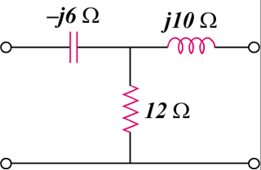

Figure 19.97

Solution

To get 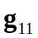 and 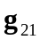, consider the circuit in Fig. (a).
V₁
(a)
+
V₂
−
I₂ = 0
+
−
I₁
j10 
12 
-j6 
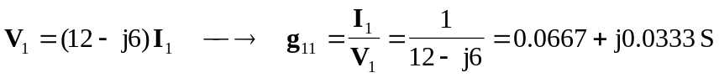
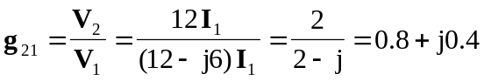

To get 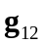 and 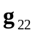, consider the circuit in Fig. (b).
(b)
I₂
+
V₁ = 0
−
I₂
j10 
12 
-j6 
I₁

